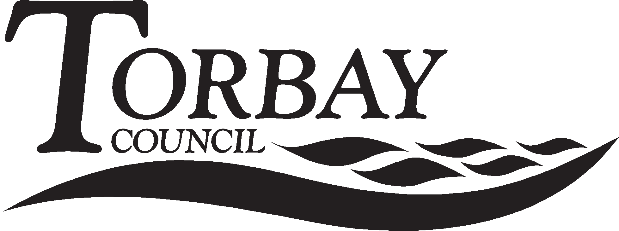
Application for Free School Meals

Your name and address:

Mr/Mrs/Miss/Ms Initial(s).............. Surname ..................................................................................................

Address ..............................................................................................................................................................

...........................................................................................................................................................................

Post Code: ....................................... Telephone ..................................................................................................

Email .............................................................. Relationship to Child(ren)..........................................................

Details about you and your partner (those living at the same address)

Mr/Mrs/ Miss/Ms | Full Legal name | Date of Birth | National Insurance Number

- Details about the children for whom you receive Child Benefit that attend a school in Torbay

Forename(s) | M/ F | Surname | Date of Birth | Name of School Attended | New School? Yes/No | If Yes - start date

- Which benefit do you receive? (Please tick all boxes that apply)

Income support |  | Child tax credit(without working tax credit) and an annual income below £16,190
Income based job seekers allowance |  | Employment and support allowance (income related)
Working Tax credit run on only |  | Universal Credit
Guaranteed element of pension credit |  | Support under part VI of the Immigration and Asylum Act 1999

5. Universal Credit
If you are in receipt of Universal Credit, is your net earned family income over £7,400 per year? (Please place an X in the appropriate box).
Your net earned income is your household income after taxes and deductions. It does not include income through Universal Credit or other benefits that you may receive.

Yes No Unsure

Please note: Contributions Based Jobseeker’s Allowance and Working Tax Credit do not qualify.

I wish Torbay Council to be able to assess my claim in future via a secure computer link with the Department for Education. I agree that Torbay Council can use the information I have provided to process my claim for free school meals and can contact other sources as allowed by law to verify my initial and continuing entitlement.

6. Declaration: I confirm that I have parental responsibility for or care of the child(ren) named on this form. As far as I know the information I have given above is correct. I will tell you immediately if my details above or circumstances change.

Your signature.......................................................................... Date...................................................................

Please return to: Student Services, Electric House, Room SF338, c/o Town Hall, Torquay TQ1 3DR or your child’s school.
Important

You no longer need to reapply; once we have your details on record we will do regular checks to see whether you are still entitled.

In order to perform these checks we need up to date details. It is therefore essential for you to let us know of any changes of benefit and name or address of the person, in your household, receiving the qualifying benefit. Incorrect details may lead us to believe that you are not entitled to free school meals.

How do I qualify?

Parents/carers who receive any of the following are entitled to free school meals:

- Universal Credit with an annual net earned income of no more than £7,400.
- Income Support
- Income-based Jobseeker’s Allowance
- Income-related Employment and Support Allowance
- Support under Part 6 of the Immigration and Asylum Act 1999
- The guarantee element of Pension Credit
- Working Tax Credit run-on (paid for the four weeks after you stop qualifying for Working Tax Credit)
- Child Tax Credit (with no Working Tax Credit) with an annual income of no more than £16,190

If you have recently become unemployed but are still receiving Working Tax Credits, you may be entitled to free school meals, please call us on (01803) 208244 for advice.

How do I apply?

- Fill out the form overleaf, including the declaration at the bottom.

- Take the completed form to your child’s school or send it to:

Student Services, Electric House, Room SF338, c/o Town Hall, Torquay TQ1 3DR

- We will then enter your details into the online system and it will tell us if you are entitled or not.

- We will then send you a letter with our decision, usually within 5-10 working days.

- If it states Authorized: you need to do nothing, we will inform the school and your child will be able to receive free school meals shortly after.

- If it states Not Authorized: If you still believe you are entitled, please call (01803) 208244 for advice, we may need you to send us evidence that you receive a qualifying benefit in this circumstance.

You do not need to send evidence with this application, if we need evidence at a later date we will contact you.
1218/0611

